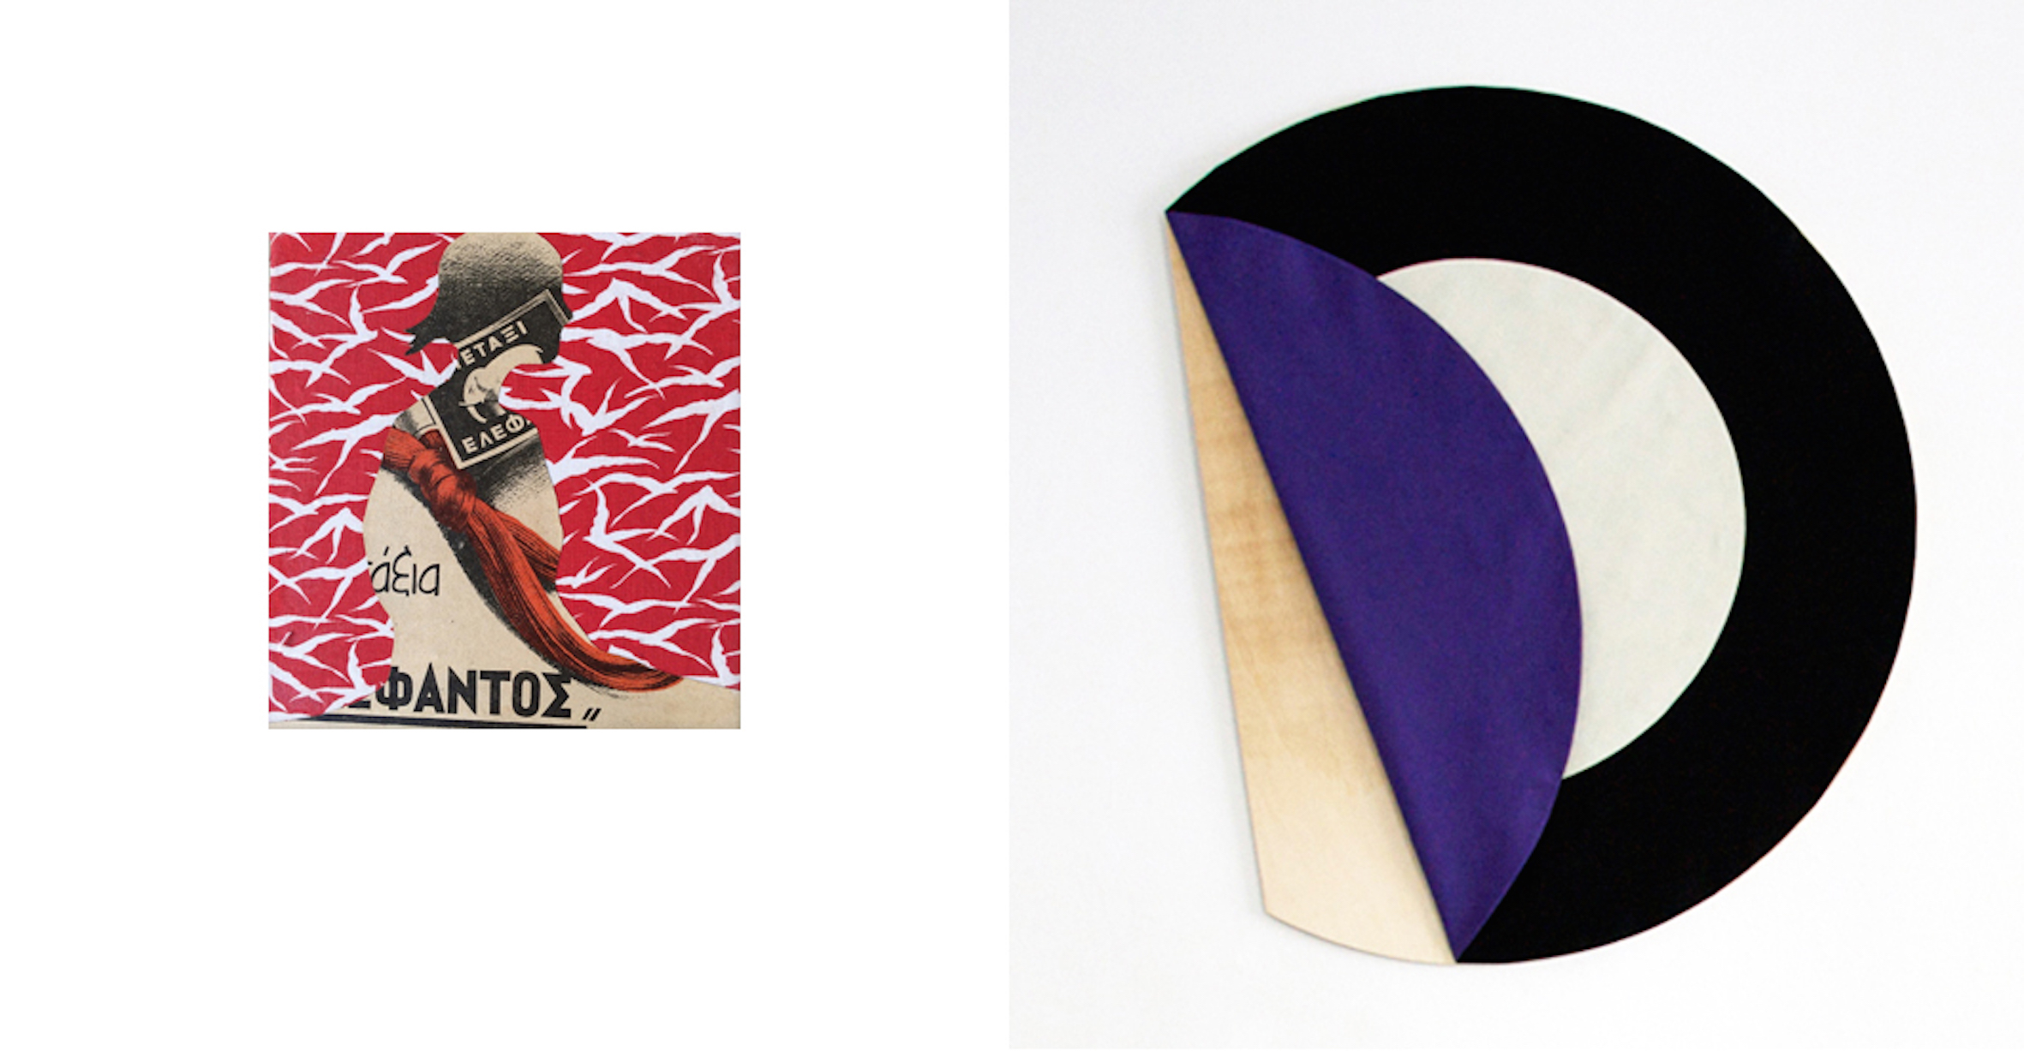
Lila Polenaki, Metaxi, 2011 Susanne Pittroff, Einräumen, 2014

Lila Polenaki – Susanne Pittroff
16.07.2015 – 31.07.2015

Gallery Françoise Heitsch's new exhibition will display works by the artists Lila Polenaki and Susanne Pittroff. As different as their works may appear at first glance, their affinity to objectness and form will eventually unite these.

Several smaller works by the Athenian artist Lila Polenaki will be exhibited. Despite their small size, they will capture the spectators’ attention. They appear like colourful flower bouquets, yet hold within an object-like nature. This impression will be strengthened by the idiosyncratically arranged fragments of images, book cut-outs, and different fabrics. The works originate directly from the artist’s cosmos and it is this process, which provides them with a fabulous vitality. Yes, indeed, we are standing in front of a fancy birthday cake, and yet we feel as overwhelmed as if we had just encountered a mesmerizing oriental story. It makes us happy to sometimes trace her working process as well as the materials she has used. This, however, does not lessen the works’ impact on us. In fact, we develop a relationship with her images, since these remind us of what has long gone. We want to thank Lila Polenaki for capturing what we have neglected, even forgotten.

The forms, which have been retained in Polenaki’s images, become three-dimensional objects in Susanne Pittroff’s works; objects, which enter into a conversation with their surrounding architecture.

Semper provided the covering of architecture with a crucial meaning. For him, the origin of architecture can be found in textiles, and more precisely, in the tent architecture of nomads. “[...] The idea of a system of material units whose attributes are pliability, suppleness, and toughness came about for the following reasons:

- to string and to bind;
- to cover, to protect, and to enclose.”*

Susanne Pittroff draws on these thoughts and shows textile objects, which strongly contrast each other in their colour set up. The circular objects appear like coloured space-filling islands and their shape points towards those ephemeral spheres, which deal with topics such as availability, enclosure, or isolation. Pittroff employs minimal means in order to reflect upon everyday orders and spatial policies.
The symbolism and the used materials consistently open up several semantic levels set within social or political contexts.

Fabrics and patterns dominate in Polenaki’s work. In Susanne Pittroff’s work, form and colour become the essential components, which not only alter the space but also our perception of it. Thus, two different realms which support and strengthen each other. On the one hand, the sublime and well thought through world in dialogue with its surrounding architecture as presented by the Munich-based artist Susanne Pittroff; on the other, a playful world that draws from everyday live with a wink as shown by the Athenian artist Lila Polenaki.

* Semper, Gottfried (1860). Chapter 3. Textiles: A General-Formal in “Style in the Technical and Tectonic Arts; or, Practical Aesthetics.” Trans. Harry F. Mallgrave (Santa Monica, 2004), p. 113

